**AUTONOMOUS MOBILE ROBOT FLEET MANAGEMENT**

*Report submitted to the SASTRA Deemed University*

*As the requirement for the course*

**MEC300 MINI PROJECT**

*Submitted by*

**Vipul Raj**

**(Reg. No.: 124161091)**

**Revanuru Sree Harsha**

**(Reg. No.: 124161087)**

**Poluri Lakshmi Chandrahas**

**(Reg. No.: 124009093)**

**May 2023**



**SCHOOL OF MECHANICAL ENGINEERING**

**THANJAVUR, TAMIL NADU, INDIA-613 401**



**SCHOOL OF MECHANICAL ENGINEERING**

**THANJAVUR - 613 401**

**Bonafide Certificate**

This is to certify that the report titled **“Autonomous Mobile Robot Fleet Management”** submitted as a requirement for the course, **MEC 300 Mini–project** for B.Tech. Mechanical (Digital Manufacturing) programme, is a bonafide record of the work done by **Mr. Vipul Raj (Reg. No. 124161091), Mr. Revanuru Sree Harsha (Reg. No. 124161087), Mr. Poluri Lakshmi Chandrahas (Reg. No. 124009093)** during the academic year 2022- 23, in the School of Mechanical Engineering, under my supervision.

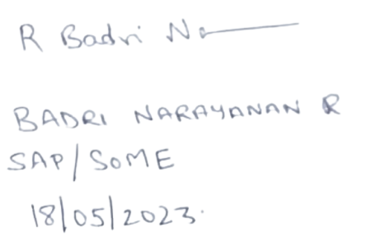

**Signature of Project Supervisior :**

**Name with Affiliation :**

**Date :**

Mini-project Viva-voce held on 19/05/2023

**Examiner 1 Examiner 2**

i



**SCHOOL OF MECHANICAL ENGINEERING**

**THANJAVUR - 613 401**

**Declaration**

We declare that the report title “**Autonomous Mobile Robot Fleet Management**” submitted by us is an original work done by us under the guidance of **Dr.Badri Narayanan R Senior Assistant Professor, School of Mechanical Engineering, SASTRA Deemed University** during the even semester of academic year 2022-23 in the **School of Mechanical Engineering**.The work is original wherever we have used material from other sources,we have given due credit and cited them in the text of the report. This report has not formed the basis for the award of any degree,diploma, associate-ship, fellowship or other similar title to any candidate of any university.

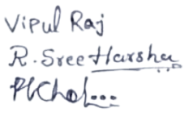

**Signature of the candidate(s) :**

**Name of the candidate(s) :** Vipul Raj

Revanuru Sree Harsha

Poluri Lakshmi Chandrahas

**Date :** 10/05/2023

ii

**ACKNOWLEDGEMENTS**

First and foremost, We praise and thank god for having everything possible.

It is a great honour to express our gratefulness to our beloved Vice Chancellor **Dr S.VAIDHYA SUBRAMANIAM**, SASTRA Deemed University, the paramount of the Institution, for his patronage and **Dr R.CHANDRAMOULI**, Registrar, SASTRA Deemed University for providing the necessary research facilities in the campus.

We are extremely thankful to **Dr S.PUGAZHENTHI,** Dean, School of Mechanical Engineering, SASTRA Deemed University for giving us this opportunity and setting a Standard for the project.

We would like to acknowledge with much appreciation the crucial role of our project guide, **Dr BADRI NARAYANAN R,** Senior Assistant Professor, for his continuous efforts in guiding us throughout the semester. His timely help can never be penned with words.

We express my deepest thanks to all the faculty members and **Shri. U Siddharth,** Ph.D Scholar of the School of the Mechanical Engineering, SASTRA Deemed University for their timely assistance in the work. Further, We would like to thank them for allowing us to perform ‘Autonomous Mobile Robot Fleet Management’ project.

We are grateful to all our well-wishers, who helped us in facing the difficulties in the successful completion of project.

iii

**Table of contents**

**Title Page No.**

Bona-fide Certificate i

Declaration ii

Acknowledgements iii

List of Figures v

Abstract vi

Abbreviations ix

1. Introduction 1
   1. Literature Survey 2
2. Objectives 5
3. Methodology 6
4. 4.1 Results 10

4.2 Discussions 16

1. Conclusion 17
2. References 18
3. Appendix 19

iv

**List of Figures**

|  |  |  |
| --- | --- | --- |
| **Figure No**. | **Title** | **Page**  **No.** |
| 3.1 | Turtlebot environment | 7 |
| 3.2 | Turtlebot world map | 7 |
| 3.3 | Turtlebot waffle | 8 |
| 3.4 | SLAM navigation | 9 |
| 4.1 | Ubuntu environment | 10 |
| 4.2 | Terminal | 10 |
| 4.3 | Turtlebot environment | 11 |
| 4.4 | Turtlebot in environment | 12 |
| 4.5 | Turtlebot in environment | 13 |
| 4.6 | Turtlebot map | 13 |
| 4.7 | Application of mapping and navigation | 14 |
| 4.8 | Multiple turtlebot in environment | 14 |
| 4.9 | Rviz map of turtlebots | 15 |

v

**Registration Number: Name:**

124161091 Vipul Raj

**Abstract**

Autonomous mobile robot are being used more and more in shop floors for execution of material movement task autonomously. It is required that the autonomous mobile robots coordinated centrally and managed so that they are able to function independently and execute the given task to reach target destination. For this purpose fleet management software is to be developed. In this work multiple ground robots were created by using simulation environments such as ROS . Mapping, Localization and Path planning operations were carried out using ROS and fleet management based on sensor data and global goals were developed using python.

**Specific Contribution**

* Installed ROS environment by giving ros installation commands through terminals.
* Imported turtlebot in ROS environment and given commands to run the turtlebot.
* Controlled turtlebot using slam navigation and mapping with respective to environment.

**Specific Learning**

* Learnt how to operate ROS in Ubuntu software to manage fleet of AMR’s.
* Learnt how to proceed and work on simulation for industry environments.

vi

**Registration Number: Name:**

124161087 Revanuru Sree Harsha

**Abstract**

As technology improves day by day, Logistic work and material transport is performed manually on shop floors. But in recent times autonomous mobile robots are proposed to perform this work with much more effectiveness. To achieve this, fleet management software needs to be implemented in multiple AMRs and reach their individual goals. In this work, This is accomplished with ROS (Robotic Operating System), which is basically a simulation environment used to simulate multiple ground robots in that environment. For this mapping, localization and path planning operations were developed such that AMRs can reach their target positions. Simulation modelling is done in Gazebo along with ROS.

**Specific Contribution**

* ROS environment has been installed by giving ROS installation commands through

terminals.

* Learnt to operate turtlebot by using slam navigation and mapping with respective

to environment.

**Specific Learning**

* Learnt how to control turtlebots by giving proper commands to the turtlebots.
* Learnt what is g-mapping and what is slam.

Vii

**Registration Number: Name:**

124009093 Poluri Lakshmi Chandrahas

**Abstract**

Fleet Management software is used to control multiple autonomous mobile robots to carry material movements from one to another place at shop floor areas or industries in order to accomplish their particular goals.This task can be centrally coordinated and functioned independently to perform work and give maximum efficiency. This work should be carried in simulation environment using ROS(Robotic Operating System) to control multiple robots.For control multiple robots, Mapping, Localization and Path planning is need to reach their target destination. Autonomous Mobile robot collects data using sensors, cameras to do interpretation and output should be given as directions, obstacle avoidance and work carried out in order to complete task.

**Specific Contribution**

* Installation of ROS is carried in Ubuntu used by giving simulation commands through terminals.
* Given necessary commands to control turtlebot simulation in ROS environment.

**Specific Learning**

* Learnt how to operate ROS and set up different environments by giving commands.
* Learnt what is rviz.

viii

**ABBREVIATION**

AMR - Autonomous Mobile Robot

ROS - Robotic Operating System

SLAM - Simultaneous Localization and Mapping

ix

**CHAPTER 1**

**INTRODUCTION**

Advanced robotic systems called autonomous mobile robots (AMRs) are made to work autonomously in changing situations without constant human supervision or control. These robots have advanced algorithms, onboard processors, and sensors that allow them to understand their environment, make decisions, and complete tasks with little to no assistance from humans. AMRs' main mission is to autonomously travel and interact with their environment in order to accomplish individual goals. They are used in many different fields and contexts, including manufacturing, logistics, healthcare, agriculture, and even housework. AMRs use a variety of technologies to see and comprehend their environment. Cameras, lidar (light detection and ranging), radar, ultrasonic sensors, and even sophisticated artificial intelligence (AI) algorithms may be among these technologies.

The robots are able to plan their movements with the help of these sensors, which gather environmental data like object detection, distance measurement, and terrain mapping. AMRs onboard computing systems interpret the sensory input in real-time, allowing the robots to build an accurate picture of their surroundings and organise their movement. This includes path planning, obstacle avoidance, and simultaneous localization and mapping (SLAM) algorithms. AMRs can adapt to changes in their surroundings and move across complicated and dynamic situations by continuously analysing the sensory input and updating their internal maps.

There are numerous applications for autonomous mobile robots. They can be used for tasks including material handling, assembly, inspection, and warehouse management in industrial settings. They can aid with the transportation of medical equipment, dispensing of drugs, and patient care in the healthcare sector. AMRs in agriculture can support automated milking in dairy farms as well as crop monitoring and harvesting. Robots that are mobile and autonomous have various benefits. They can boost productivity and free up human workers to conduct more challenging and valuable activities by finishing boring or physically demanding duties. They can also improve safety by supervising risky or hazardous activities in places like nuclear power plants or disaster areas. AMRs may also save costs, increase operational effectiveness, and better utilize available resources.

1

**1.1. Literature survey**

1. Hazik, Jakub, Martin Dekan, Peter Beno, and Frantisek Duchon. "Fleet Management System for an Industry Environment." Journal of Robotics and Control (JRC) 3, no. 6 (2022) : 779 -789. Studied about implementation of fleet of AMR robots, process operated in synchronization mode, AMR Fleet is a supervisory system that keeps track of how other robots move and give important information about work area, charging station, e.t.c .
2. Vongbunyong, Supachai, Salil Parth Tripathi, Kitti Thamrongaphichartkul, Nitisak Worrasittichai, Aphisit Takutruea, and Teeraya Prayongrak. "Simulation of Autonomous Mobile Robot System for Food Delivery in In-patient Ward with Unity" .IEEE, 2020. The simulation software is developed in Unity platform to study the operations of AMRs in various scenarios. AMR fleet working carried out in unity software to develop a specific problematic simulation program.
3. Souto, Alexandre, Pedro Alexandre Prates, André Lourenço, Mazoon S. Al Maamari, Francisco Marques, David Taranta, Luís DoÓ, Ricardo Mendonça, and José Barata. "Fleet Management System for Autonomous Mobile Robots in Secure Shop-floor Environments." In 2021 IEEE 30th International Symposium on Industrial Electronics (ISIE), pp. 1-6. IEEE, 2021.Learned about how the FMS was tested in an environment that mimic same challenges present in shop floor. By deploying a robot-to-cloud architecture using the Rapyuta cloud platform, FMS becomes an integrated enterprise with the aim of high-level factory decision-making.
4. Bøgh, Simon, Peter Gjøl Jensen, Martin Kristjansen, Kim Guldstrand Larsen, and Ulrik Nyman. "Distributed Fleet Management in Noisy Environments via Model-Predictive Control”. In Proceedings of the International Conference on Automated Planning and Scheduling, vol. 32, pp. 565-573, 2022. A fleet of autonomous mobile robots executing pickup and delivery jobs in a stochastic environment using dynamic route planning. A demonstration of how to convert such planning issues into Euclidian Markov decision processes and use the Uppal stratego tool to resolve them was made.

2

1. Martin, Lancelot, James Gao, Alister Wilson, Chi Hieu Le, and Marcus de Ree. "Autonomous mobile robots in high occupancy aerospace manufacturing." (2021): 133-138. providing the robot with real-time data by utilising built-in sensor networks and IoT. When implemented and evaluated against the standard, BAE Systems can fully justify the employment of robots in the environment
2. Čech, Martin, Pavel Wicher, Radim Lenort, Tomáš Malčic, Jiří David, David Holman, David Staš, and Jiří Záruba. "Autonomous mobile robot technology for supplying assembly lines in the automotive industry." Acta logistica 7, no. 2 (2020): 103-109. The entire travel and handling time of the AMRs is used to calculate the necessary number of AMRs. The handling tasks carried out by AMR at the work stations take so long that a single pallet system is essentially impractical. The two-pallet method, however, is typical in the automotive sector.
3. van Duijkeren, Niels, Luigi Palmieri, Ralph Lange, and Alexander Kleiner. "An Industrial Perspective on Multi-Agent Decision Making for Interoperable Robot Navigation following the VDA5050 Standard." The motion planner's job is to steer the robot swiftly and smoothly towards the established objective. For the majority of the aforementioned functional levels, there are numerous efforts on distributed coordination and cooperative planning that could strengthen the robustness of the execution of multi-agent plans.

8. Narcis Miguel, Diogo Santos, Isabel Praca, Martin Praddaude “ A machine

learning approach to anomaly detection for collaborative AMR with arms.” A

mobile manipulator with a modular design, TIAGO integrates vision, navi-

gation, manipulation, and human-robot interaction (HRI) capabilities. The

task dependence of the existing AD tools for robotic arm motions based on

machine Learning (ML) is evident in the fact that the training of the selected ML

approach necessitates information particular to the desired arm motion

.

3

1. SESTO Robotic, “An intelligent fleet management system for AMRs.” In order to prevent route-block situations, which are analogous to traffic bottlenecks on the road and lengthen the travel time required by AMRs to complete delivery jobs, a decent fleet management solution should incorporate path planning capabilities. Additionally, the fleet management system must be able to device an alternate route in case the mobile robot runs into road blocks like trolleys that prevent it from reaching its objective. <https://youtu.be/pD8Oz4cUX2s>
2. Mecharithm - Robotics and mechatronic ”Localization, Mapping and SLAM using

g-mapping” Learned about SLAM, mapping, and localization, Launching the

G-Mapping, Installing the G-Mapping package in Gazebo, and utilising our robot

lidar to create a map.

<https://youtu.be/ueSmN_VxNPg>

4

**CHAPTER 2**

**OBJECTIVES**

1. Installing ROS (Robotic Operating System) in Ubuntu for carrying our project as ROS is working with linux system.
2. Creating a workspace to simulate robot for doing according to needs.
3. Implementing turtlebot in virtually created workspace which is basically a robot model simulation software for showing aim of our project.
4. This project need a simulation software for simulate mobile robot for moving in a particular workspace.
5. For mapping robot, Using g-mapping and for navigation we use navigation command to navigate robot in according to map.
6. SLAM (Simultaneous localization and mapping) is used for installing g-mapping for multiple robots.
7. To show that autonomous mobile robot is moving in a shop floor to do work like carrying loads from one place to other (or) in a manufacturing plant to carrying machine parts from one machine to another without collision to each other and do their work independently.

5

**CHAPTER 3**

**METHODOLOGY**

The methodology procedure to accomplish the simulation of turtlebots are as follows:

In this case, Simulation modelling is done in gazebo along with ROS. So, To install ROS

the following approach is:

1. Firstly, Install virtual box which is a software used to run different platforms in the same pc. So we have installed virtual box in order to run Ubuntu.
2. Ubuntu is a free and open-source operating system based on the Linux kernel. key features of Ubuntu is its package management system, which allows users to easily install and update software.
3. ROS environment installation is possible by giving ROS installation commands through terminals.

After installing ROS, For setting up the environment can be attained by giving proper commands through terminals in that can install the respective environment. The environment that have created should consists of different things, objects and tables.

In map model one way paths,bi-directional paths, areas with intersections and cross-sections and these should be evaluated in simulation environments.Implement Fleet management for a group of robots in ROS environment.

6

Here in ROS, Turtlebot3 a robot is imported for simulation. Turtlebot is a robot with open-source software. With the TurtleBot robot simulation, you can perform the same tasks without the risk of damaging your real robot. 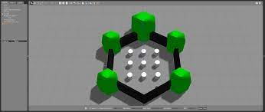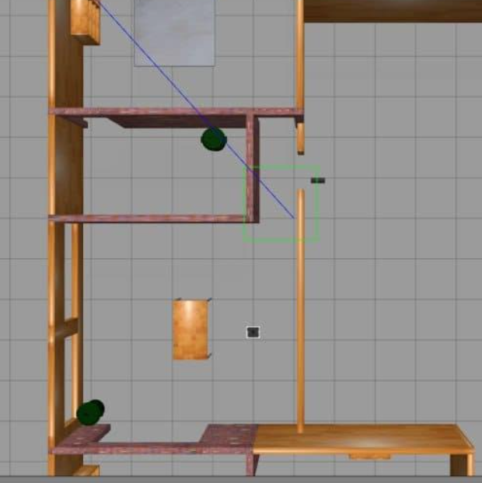

**Fig 3.1 Turtlebot environment Fig 3.2 Turtlebot world map**

Importing turtlebot, To launch and control turtlebot, To activate ROS can be achieved

by assigning proper simulation commands. The simulation commands are as follows:

To activate ros : Source/opt/ros/noetic/setup.bash

To import turtlebot : export Turtlebot3_MODEL= waffle_pi

To launch turtlebot : roslaunch turtlebot3_ gazebo turtlebot3_world.launch

7

To control turtlebot : 1.Export TURTLEBOT3_MODEL=WAFFLE

2.ros launch turtlebot3_teleopturtlebot3_teleop_key.launch

For g-mapping : roslaunch turtlebot3_slam turtlebot3_slam.launchslam

methods:= g-mapping

To launch rviz : rviz

Where, rviz is a powerful 3D visualization software tool used for merging robot to the map.

After successfully installing the selected turtlebot environment. The next step to proceed further is to launch a turtlebot3 in that environment and can test the turtlebot movement and how it is adapting to those situations by pressing W,A,D,X keys. W key command gives the movement of turtlebot in top direction, X key command gives the movement of turtlebot in bottom direction,D key command gives the movement of turtlebot in right direction and A key command gives the movement of turtlebot in left direction.

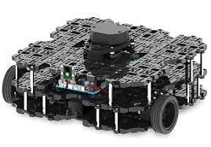

**Fig 3.3 Turtlebot waffle**

To launch multiple turtlebots in that selected turtlebot3 environment so that can assess how the turtlebots movement are to be done in that respective environment.

8

Install G-mapping for multiple robots using SLAM (Simultaneous Localization and Mapping) navigation by giving proper commands to the turtlebots. A map-creating programme called G-mapping makes use of the Open Slam software library

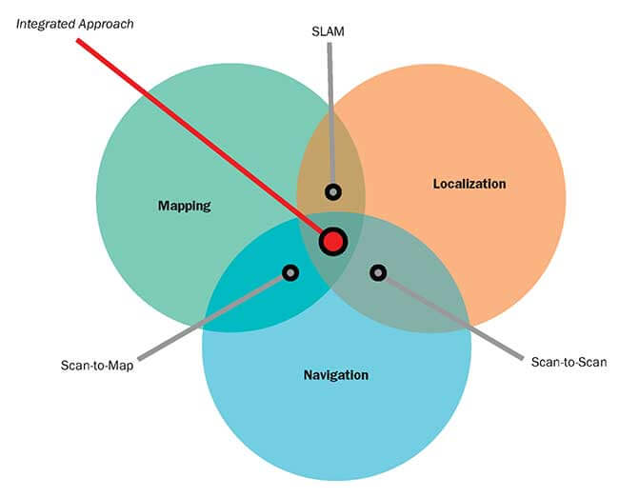

**Fig 3.4 SLAM navigation**

9

**CHAPTER 4**

**4.1. RESULTS**

After successfully installation of virtual box ,Run Ubuntu inside it and then ROS

was introduced which is basically a robotic environment by giving proper commands

through terminals.

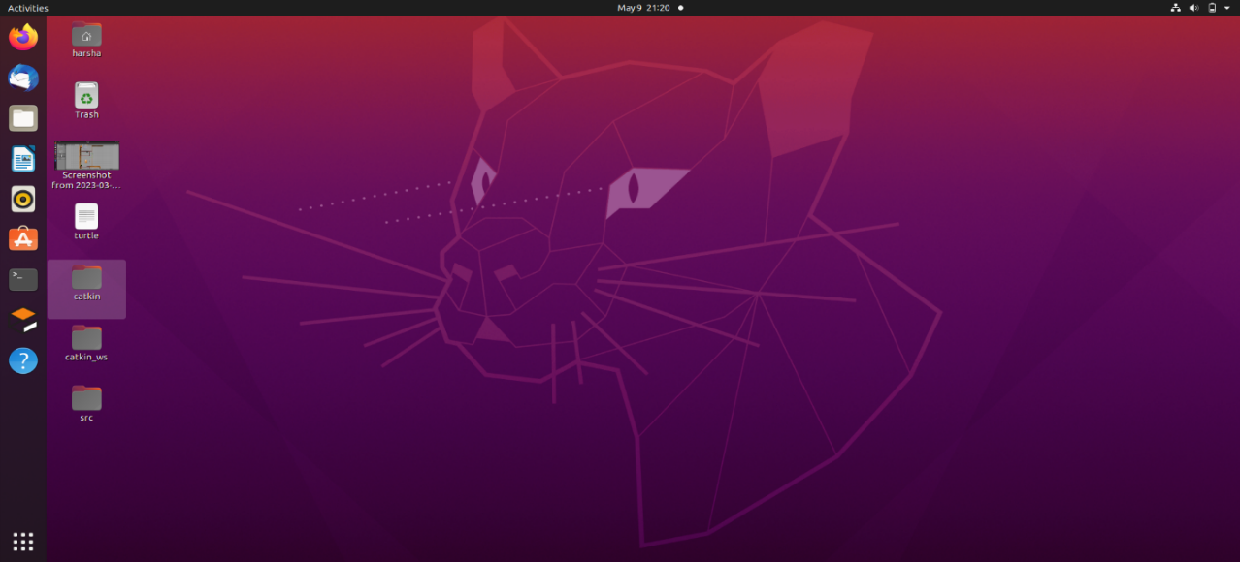

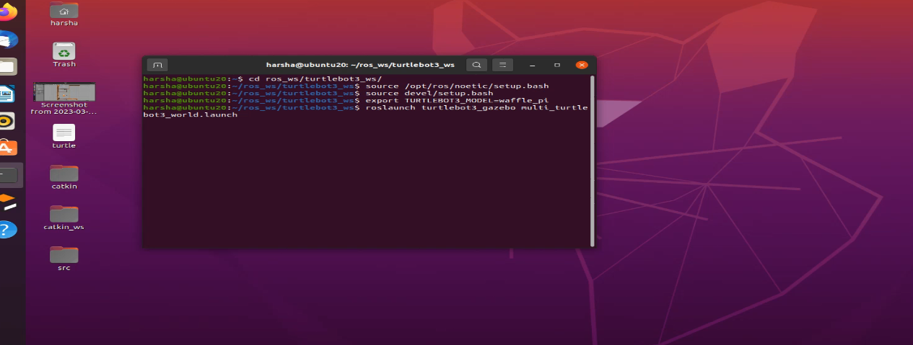**Fig 4.1Ubuntu Environment**

**Fig 4.2 Terminal**

10

For setting up the robotic simulation environment, Select the type of environment which is suitable where some environments required a huge graphics to load that particular environment.So, decided to do incorporate particular environment of low level graphics called turtlebot3 world environment where we import turtlebots to

run in that environment and reach their self goals.



**Fig 4.3 Turtlebot Environment**

11

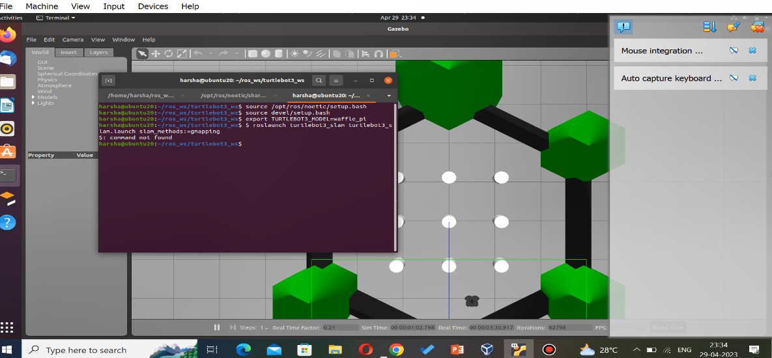After suceessfully installing the selected turtlebot3 environment. Turtlebot can be incorporated in a particular environment and test that particular turtlebot how it is behaving in a particular environment and observe by pressing following keys (W,X,A,D) gives the movement of turtlebot. The importation of a turtlebot, launching of a turtlebot and controlling of a turtlebot and merging of robot with map can be achieved by implementing simulated commands.

**Fig 4.4 Turtlebot in environment**

**12**

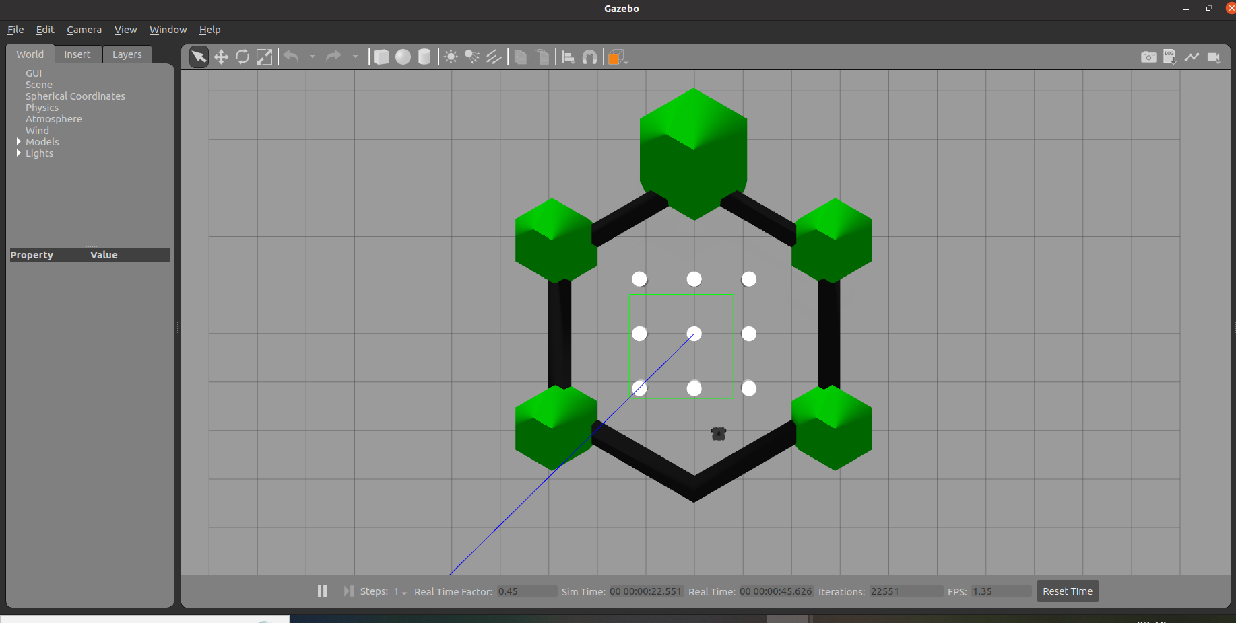

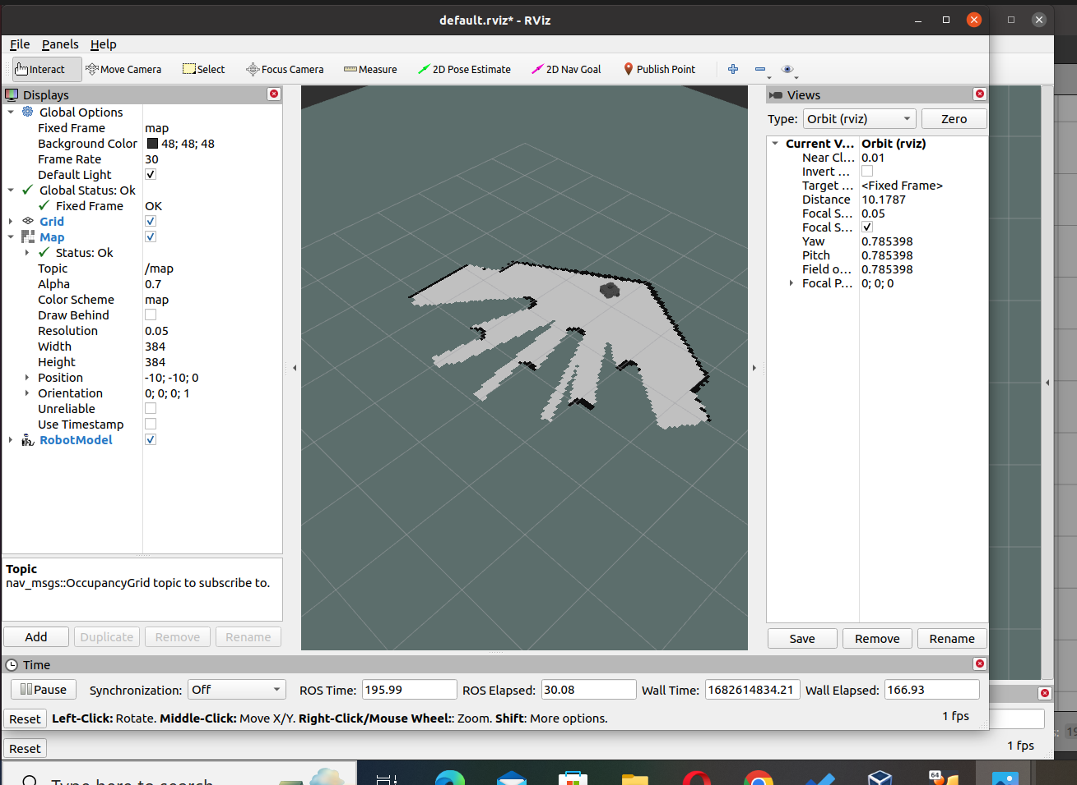**Fig.4.5 Turtlebot in environm**

**Fig.4.6 Turtlebot map**

13

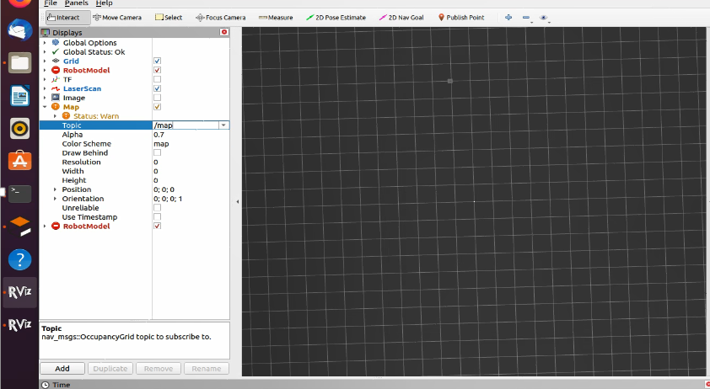 Implementing the multiple turtlebots in the respective turtlebot3 environment. That can be obtained by giving necessary commands through terminals and can run the multiple turtlebots in different directions by pressing keys W,A,X,D and g-mapping can be done for multiple turtlebots by using SLAM navigation by giving proper commands through terminals.

**Fig.4.7 Application of mapping and navigation**

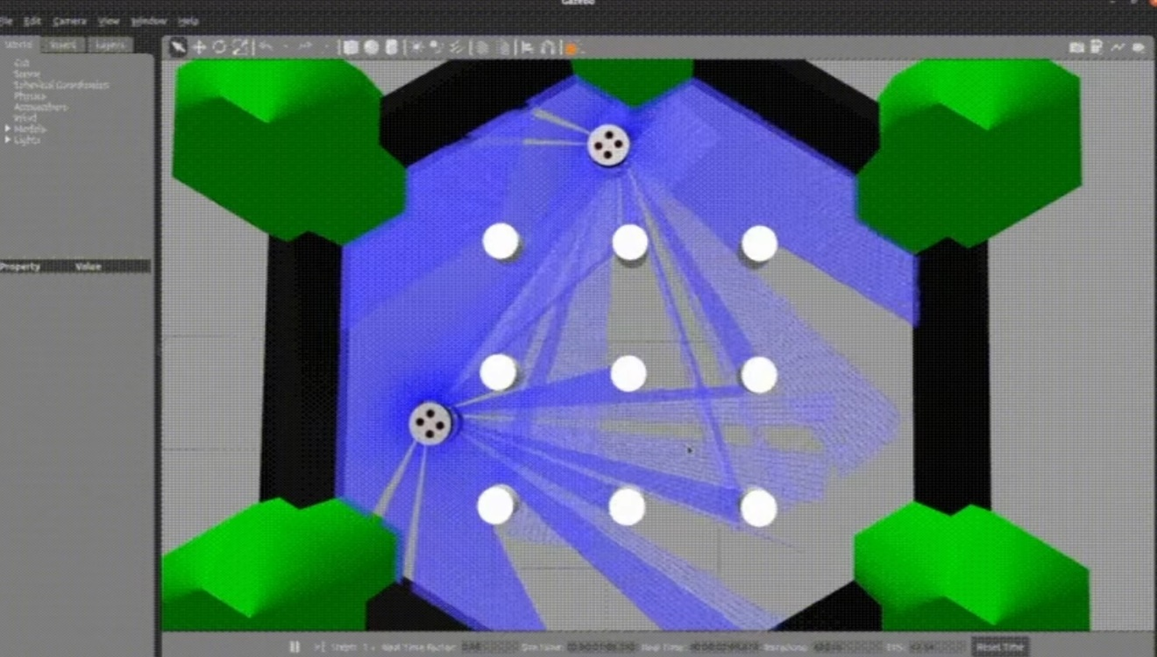

**Fig.4.8 Multiple turtlebot in environment**

14

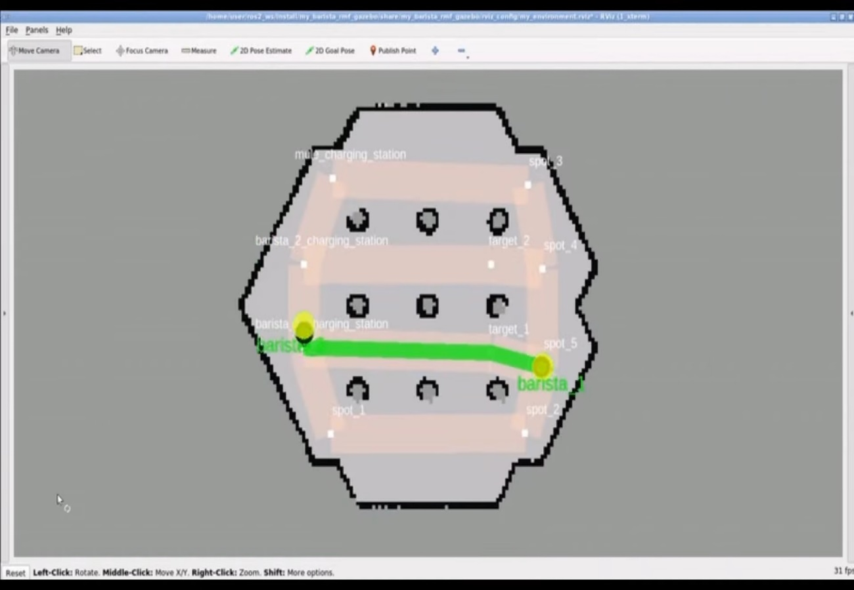

**Fig.4.9 Rviz map of turtlebots**

15

**4.2. DISCUSSION**

In this scenario, When multiple turtlebots are moving simultaneously each other to perform their work such that turtlebots can move safely without any occurrence of collision with objects and other turtlebots and to achieve their primary tasks and individual goals

Initially, To perform the simulation of turtlebots to carry out their tasks got some errors in running commands to perform g-mapping, importing turtlebots and also in setting up the ware house environment we need high graphics to load that particular environment. So, After thorough analysis to tackle the problem.

16

**CHAPTER 5**

**CONCLUSION**

This report highlights that how multiple ground robots reach their target positions without facing

any hinderance. Single ground robot is installed in respective turtlebot3 environment by giving proper commands through terminals and tested the movement of turtlebots top, bottom ,right and left is achieved by pressing following keys W,X,A,D. Here after, implemented multiple ground robots in that particular environment and test how well it can adapt to those situations and face challenges. This is achieved by indicating proper codes through terminals. Merging the ground robots with the map through rviz, where rviz is a ros visualization software which is a powerful 3D tool used to end with command, then run multiple ground robots in the environment by executing mapping, localization and navigation controls and made them as ground robots to reach their individual goals.

17

**CHAPTER 6**

**REFERENCES**

1. Jakub Hažík, Martin Dekan, Peter Beňo, František Duchoň, Fleet management system for an industry environment, November 2022
2. Alexandre Souto, Fleet Management System for AMR in Secure shop floor Environments,

1 November 2021.

1. Supachai Vongbunyong, Nitisak Worrasittichai, Salil Parth Tripathi, Aphisit Takutruea, Simulation of Autonomous mobile Robot System for food delivery in In-patient ward with

Unity, October 2022.

1. Simon Bogh, Peter Gjol Jensen, Martin Kristjansen, Kim Guldstrand Larsen, Ulrik Nyman,

Distributed fleet management in Noisy environments via Model predictive control, April 2021.

1. Lancelot Martin, James Gao, Aliser Wilson, Chi Hieu Le, Marcus de Ree, Autonomous Mobile Robots in High Occupancy Aerospace Manfacturing.
2. Martin Cech, Pavel Wicher, Radim Lenort, Tomas Malcic, Jiri David, David Holman, David Stas, Jiri Zaruba, Autonomous mobile robot technology for supplying assembly lines in the automotive industry.
3. Niels van Duijkiren, Luigi Palmieri, Ralph Lange and Alexander Kliener, An industrial Perspective on Multi-Agent Decision making for interperable robot navigation following the VDA5050 Standard.
4. Narcis Miguel, Diogo Santos, Isabel Praca, Martin Praddaude, A machine-learning approach to anomaly detection for collaborative AMR with Arms.
5. SESTO Robotic, An intelligent fleet management system for AMRs,

Link: <https://youtu.be/pD8Oz4cUX2s>.

1. Mecharithm - Robotics and mechatronics, Localization, Mapping and SLAM using g-mapping package,

Link: <https://youtu.be/ueSmN_VxNPg>.

18

**Peer Evaluation Form for Group Work**

**Name: Vipul Raj (124161091)**

|  |  |  |
| --- | --- | --- |
| Evaluation Criteria | Group member:  Revanuru Sree Harsha | Group member:  Poluri Lakshmi Chandrahas |
| Attends group meetings regularly and arrives on time | 4 | 4 |
| Contributes meaningfully to group discussions | 4 | 4 |
| Completes group assignments on time | 4 | 4 |
| Prepares work in a quality manner | 4 | 4 |
| Demonstrates a cooperative and supportive attitude | 4 | 4 |
| Contributes significantly to the success of the mini project | 4 | 4 |
| TOTALS | 24 | 24 |

19

## Feedback on team dynamics:

* 1. **How effectively did your group work?**

We had a great bond among us and so we worked very actively and shared our ideas

openly and took suggestions in a healthy way and finished well before the deadline.

## Were the behaviors of any of your team members particularly valuable or detrimental to the team? Explain.

No, all my teammates are my previous friends in college and so we know each

other and I am so comfortable around them.

## What did you learn about working in a group from this project that will carry into your next group experience?

I learnt how to communicate openly; it helps in creating a healthy atmosphere

which is necessary while working as a team. I will carry forward this in my job

career too.

20

# **Peer Evaluation Form for Group Work**

**Name: Revanuru Sree Harsha (124161087)**

|  |  |  |
| --- | --- | --- |
| Evaluation Criteria | Group member:  Vipul Raj | Group member: Poluri Lakshmi Chandrahas |
| Attends group meetings regularly and arrives on time | 4 | 4 |
| Contributes meaningfully to group discussions | 4 | 4 |
| Completes group assignments on time | 4 | 4 |
| Prepares work in a quality manner | 4 | 4 |
| Demonstrates a cooperative and supportive attitude | 4 | 4 |
| Contributes significantly to the success of the mini project | 4 | 4 |
| TOTALS | 24 | 24 |

21

## Feedback on team dynamics:

1. **How effectively did your group work?**

Right from formulating the problem to fabricating the circuit and obtaining the results,

all of us took equal interest and worked smartly. We delegated work amongst ourselves

to ensure that the project is always progressing.

## Were the behaviors of any of your team members particularly valuable or detrimental to the team? Explain.

All of us were skilled in different domains of the project. We had good discipline

and time management as common traits and we gelled really well throughout the

project tenure.

## What did you learn about working in a group from this project that will carry into your next group experience?

One very important learning that I had was managing the schedules and planning for

the work that we were supposed to carry out. Mere following the schedule to our best

helped us be stress- free.

22

**Peer Evaluation Form for Group Work**

|  |  |  |
| --- | --- | --- |
| Evaluation Criteria | Group member:  Vipul Raj | Group member:  Revanuru Sree Harsha |
| Attends group meetings regularly and arrives on time | 4 | 4 |
| Contributes meaningfully to group discussions | 4 | 4 |
| Completes group assignments on time | 4 | 4 |
| Prepares work in a quality manner | 4 | 4 |
| Demonstrates a cooperative and supportive attitude | 4 | 4 |
| Contributes significantly to the success of the mini project | 4 | 4 |
| TOTALS | 24 | 24 |

**Name: Poluri Lakshmi Chandrahas**

23

## Feedback on team dynamics:

1. **How effectively did your group work?**

My team was extremely supportive and helpful throughout the project. Each one tried

to contribute in their own significant way in order to complete the project in an organized

manner. We were highly motivated throughout this venture facing challenges with

coherence and determination.

## Were the behaviors of any of your team members particularly valuable or detrimental to the team? Explain.

This project involved a predominant exposure to cross disciplinary departments. My

team members were extremely cooperative and we were able to learn and implement

the concepts. All of us gave valuable suggestions for the betterment of the project.

## What did you learn about working in a group from this project that will carry into your next group experience?

This project was a learning curve for me. I picked up a lot of things during the course

and one particular aspect that I would like to carry forward is the ability to respect a

second opinion and value it when in a diverse group of thinking minds.

24

**Self-Evaluation Form for Group Work**

**Name: Vipul Raj (124161091)**

|  |  |  |  |
| --- | --- | --- | --- |
|  | Seldom | Sometimes | Often |
| Contributed good ideas |  |  | Yes |
| Listened to and respected the ideas of others |  |  | Yes |
| Compromised and cooperated |  |  | Yes |
| Took initiative where needed |  |  | Yes |
| Came to meetings prepared |  |  | Yes |
| Communicated effectively with teammates |  |  | Yes |
| Did my share of the work |  |  | yes |

**My greatest strengths as a team member are:**

I am good at making plans and schedules for us to work. I always comply with my

teammates' opinion and arrive at a middle ground for a solution.

## The group work skills I plan to work to improve are:

I would like to make myself even more efficient by managing my time properly.

I plan to improve on submitting my results in a more concise manner.

25

**Self-Evaluation Form for Group Work**

**Name: Revanuru Sree Harsha (124161087)**

|  |  |  |  |
| --- | --- | --- | --- |
|  | Seldom | Sometimes | Often |
| Contributed good ideas |  |  | Yes |
| Listened to and respected the ideas of others |  |  | Yes |
| Compromised and cooperated |  |  | Yes |
| Took initiative where needed |  |  | Yes |
| Came to meetings prepared |  |  | Yes |
| Communicated effectively with teammates |  |  | Yes |
| Did my share of the work |  |  | yes |

**My greatest strengths as a team member are:**

I am an extremely motivated person.There were multiple instances when the morale

of the team took a toll, I made sure this didn’t affect the overall moral quotient and

kept my teammates actuated. I strongly believe that my strengths have contributed in

bringing a positive fruition to the project.

**The group work skills I plan to work to improve are**:

Patience is a virtue and I think I need to work on it. I tend to get a little restless.

26

**Self-Evaluation Form for Group Work**

**Name: Poluri Lakshmi Chandrahas (124009093)**

|  |  |  |  |
| --- | --- | --- | --- |
|  | Seldom | Sometimes | Often |
| Contributed good ideas |  |  | Yes |
| Listened to and respected the ideas of others |  |  | Yes |
| Compromised and cooperated |  |  | Yes |
| Took initiative where needed |  |  | Yes |
| Came to meetings prepared |  |  | Yes |
| Communicated effectively with teammates |  |  | Yes |
| Did my share of the work |  |  | yes |

**My greatest strengths as a team member are:**

Encourage team and make the people work easily with me.

**The group work skills I plan to work to improve are:**

1. Communication skills and handling pressure.
2. Not to get mentally down when things didn’t work out well.

27

**CHAPTER 7**

**APPENDIX**

**7.1. Similarity Check Report**

**AUTONOMOUS MOBILE ROBOT FLEET MANAGEMENT**

**___________________________________________________________________**

ORIGINALITY REPORT

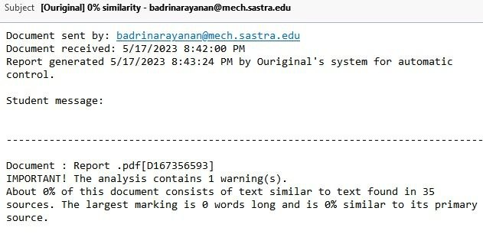

28